**Name-Ujjawal Mandhani**

**Batch-F6**

**Enroll No.-9918103237**

**PRACTICE SESSION**

**#iv)**

**from bs4 import BeautifulSoup**

**soup = BeautifulSoup("<html><p>This is <b>invalid HTML</p></html>", "html.parser")**

**#v)**

**import requests**

**url = raw_input("Enter a website to extract the URL's from: ")**

**r = requests.get("http://" +url)**

**data = r.text**

**soup = BeautifulSoup(data)**

**for link in soup.find_all('a')**

**print(link.get('href'))**

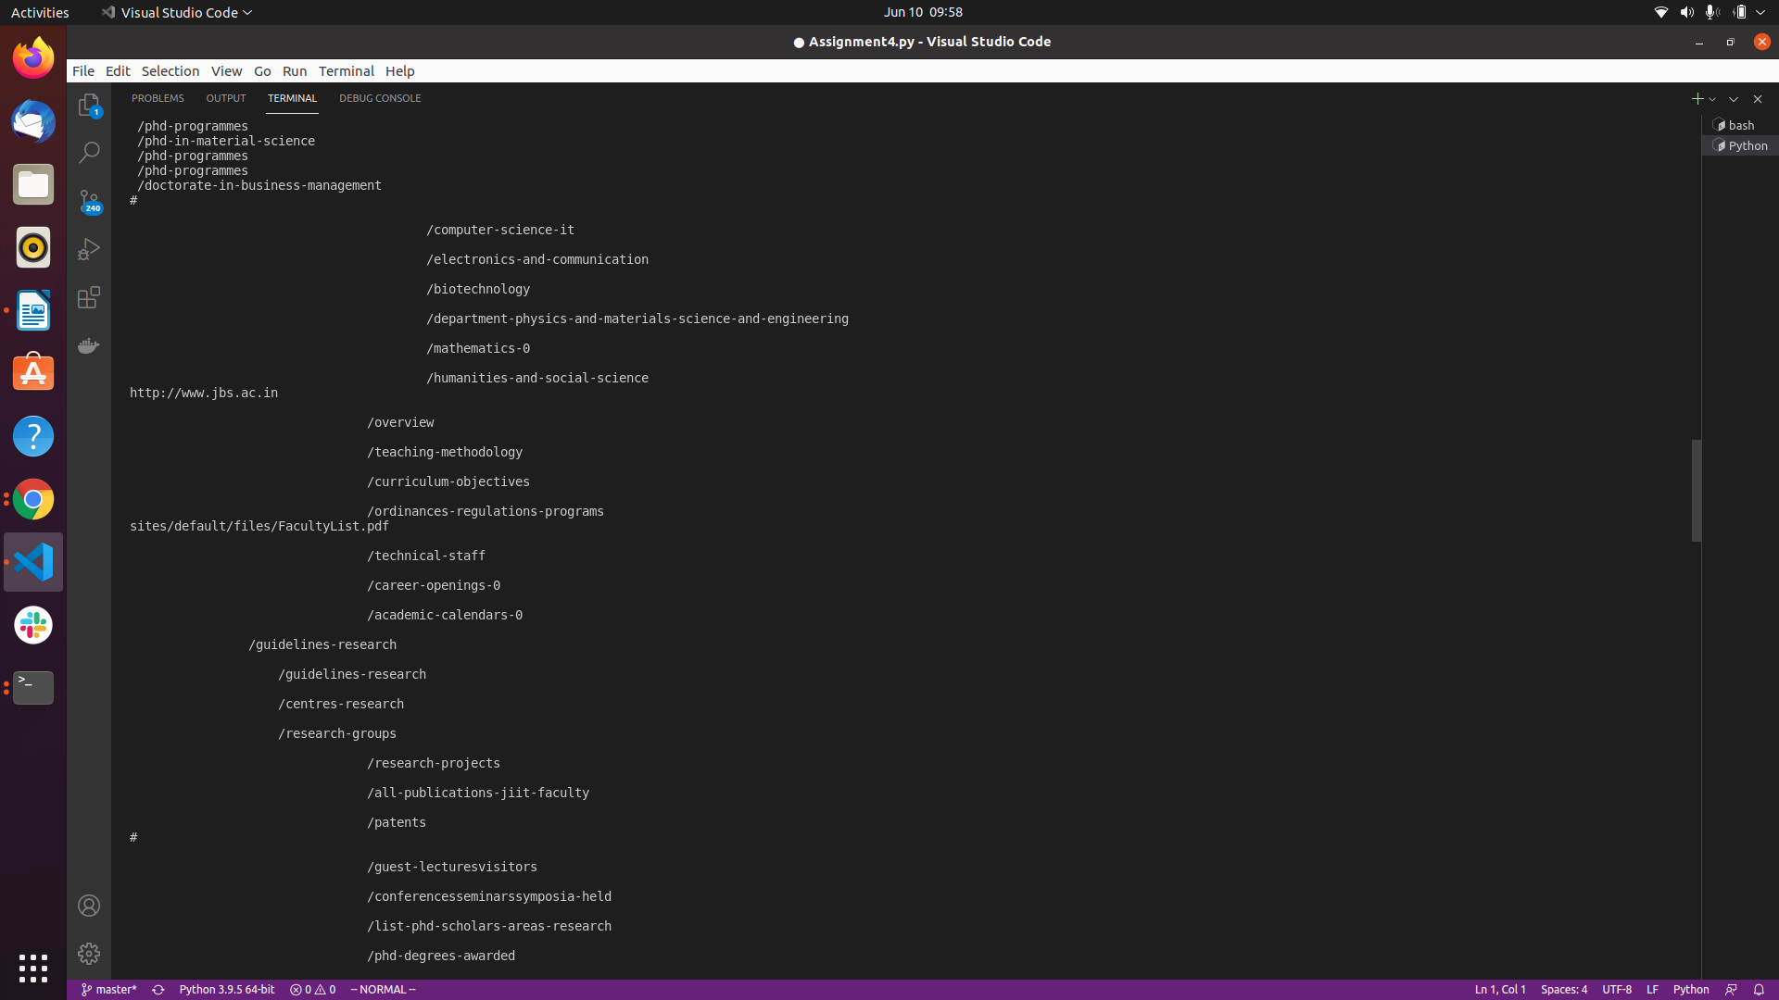

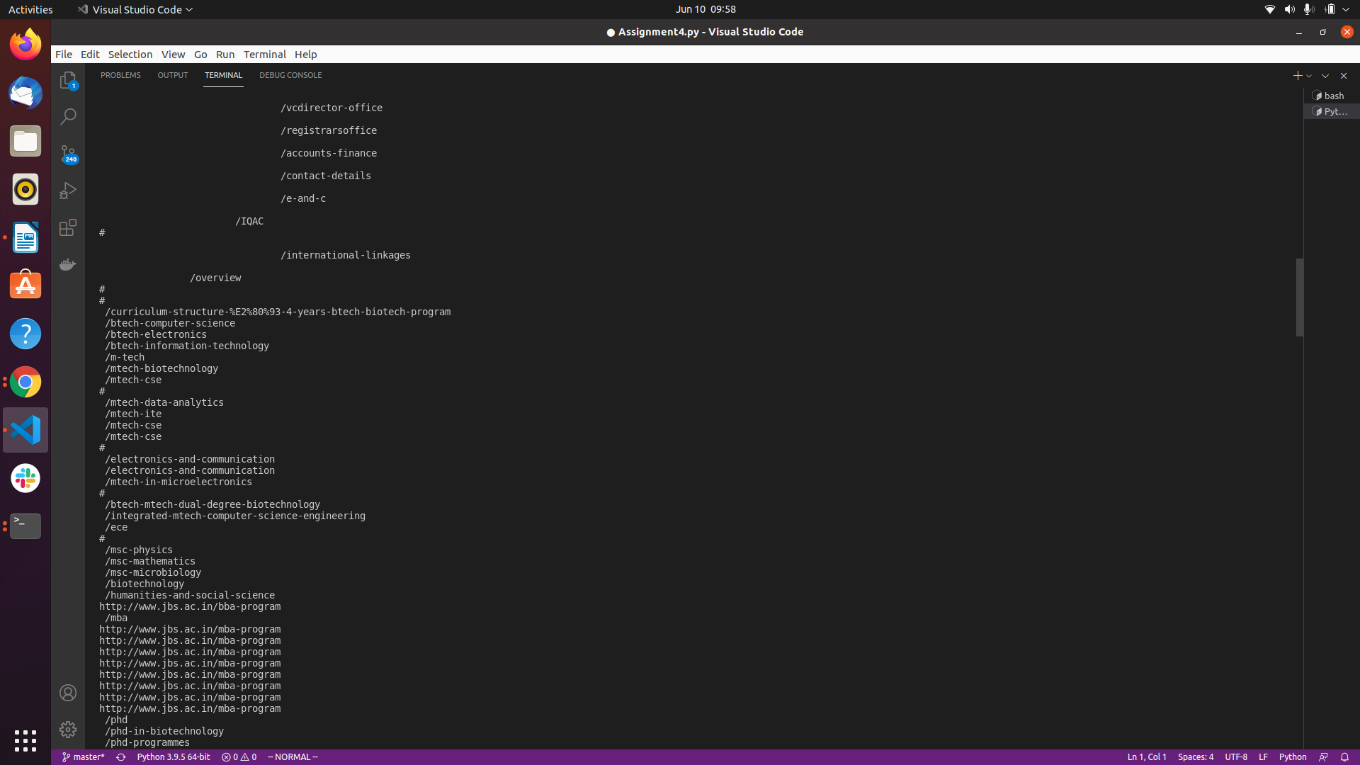

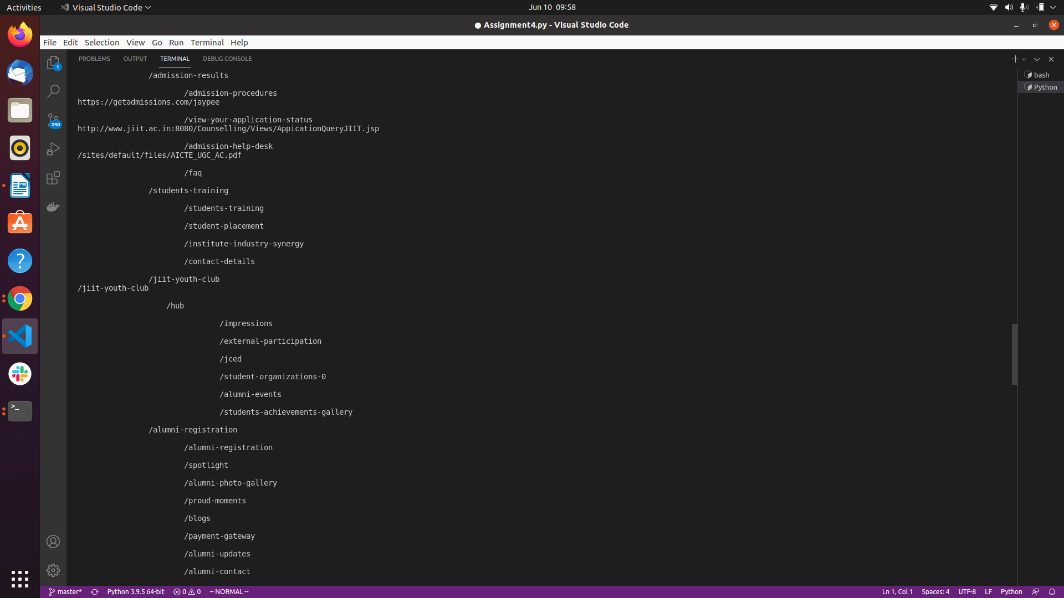



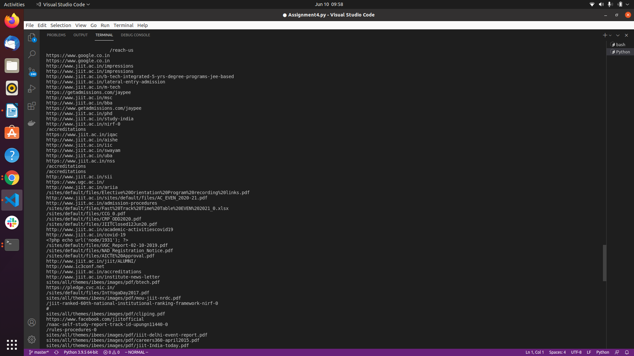

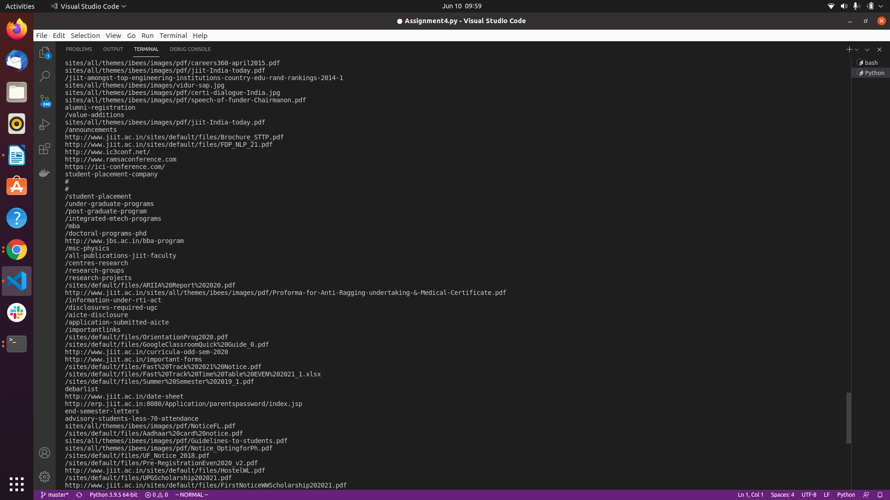

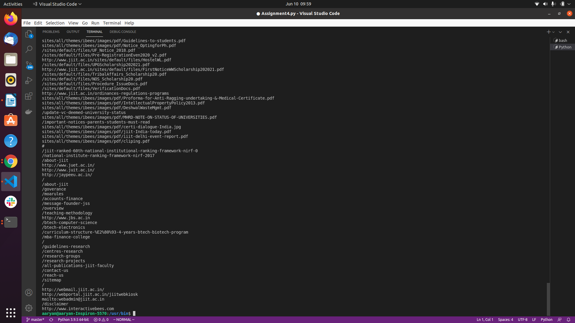

**#vi)**

**from bs4 import BeautifulSoup**

**import requests**

**req = requests.get('https://en.wikipedia.org/wiki/Python_(programming_language)')**

**soup = BeautifulSoup(req.text, "lxml")**

**print(soup.title)**

**print(soup.title.name)**

**print(soup.title.string)**

**from bs4 import BeautifulSoup**

**import requests**

**req = requests.get('https://en.wikipedia.org/wiki/Python_(programming_language)')**

**soup = BeautifulSoup(req.text, "lxml")**

**print(soup.title)**

**print(soup.title.name)**

**print(soup.title.string)**

**#vii)**

**print(soup.h1)**

**print(soup.h1.string)**

**#vii)**

**soup.h1['class'] = 'firstHeading, mainHeading'**

**soup.h1.string.replace_with("Python ‐ Programming Language")**

**del soup.h1['lang']**

**del soup.h1['id']**

**print(soup.h1)**